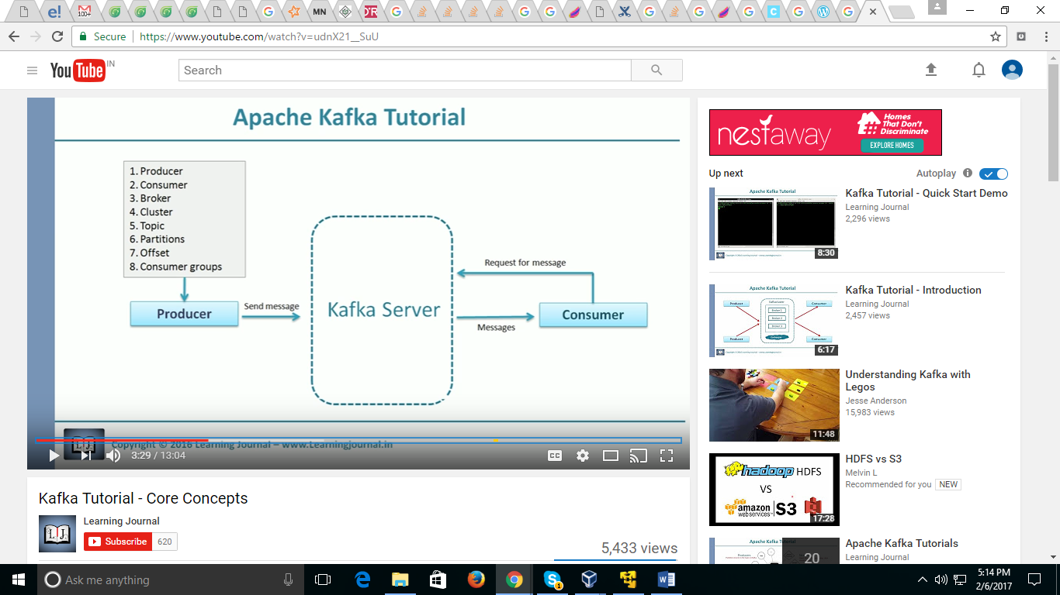

Hi Karthik

You can view the oldest or newest messages, or you can specify a starting offset where to start reading the messages from

Kafka is a message queue reimagined as a distributed commit log. What that means is that messages are not deleted when consumed. Instead they are all kept on the broker (like a log file keeps line items one after another). All new messages published are appended to the end of the queue (called a topic in Kafka). So message 0 is actually the oldest message, like the first line is a log file. The “head” of the queue is an pointer, or cursor, or in Kafka-speak an “offset” which is maintained for each consumers view of what the last processed message is for that consumer. If we have message 0, 1, and 2 in a topic then when a consumer confirms the sucessful processing of message 0 (a commit in Kafka-speak), the message is not deleted, but rather, the consumers offset is simply increased to 1 to indicate the current “head” of the queue for that particular client

The beauty of the Kafka model is that is trivially easy to go back in time and replay messages. All that needs to happen is for the consumer to change it’s offset to an earlier point in time.

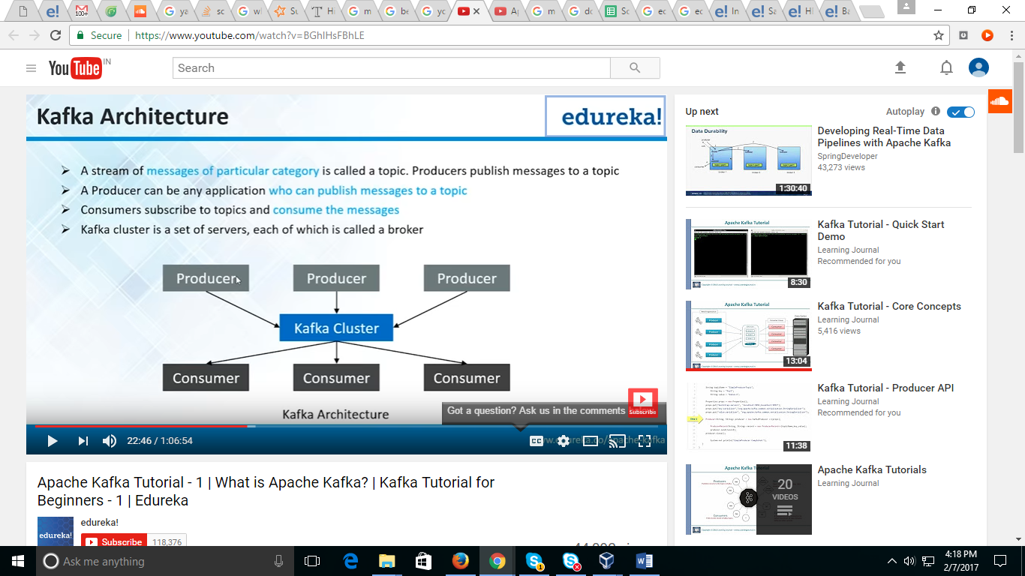

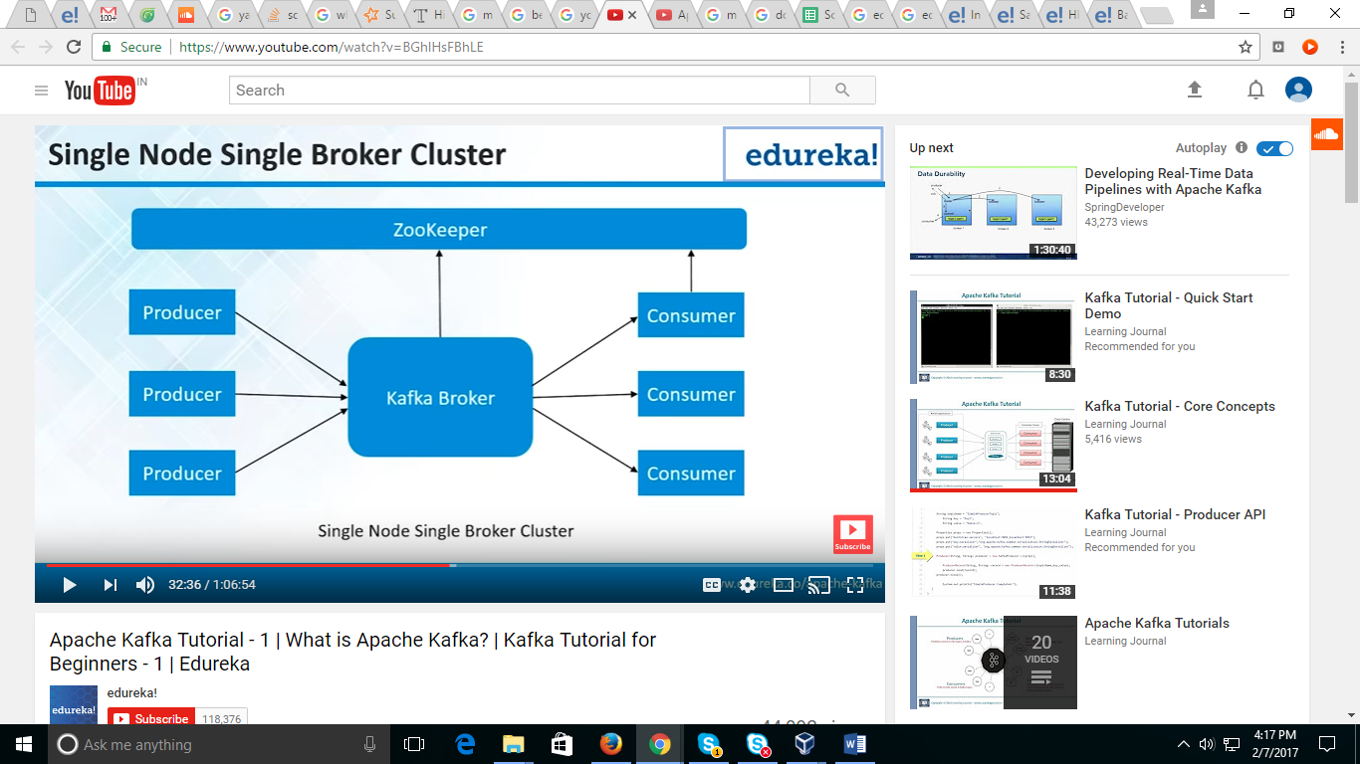

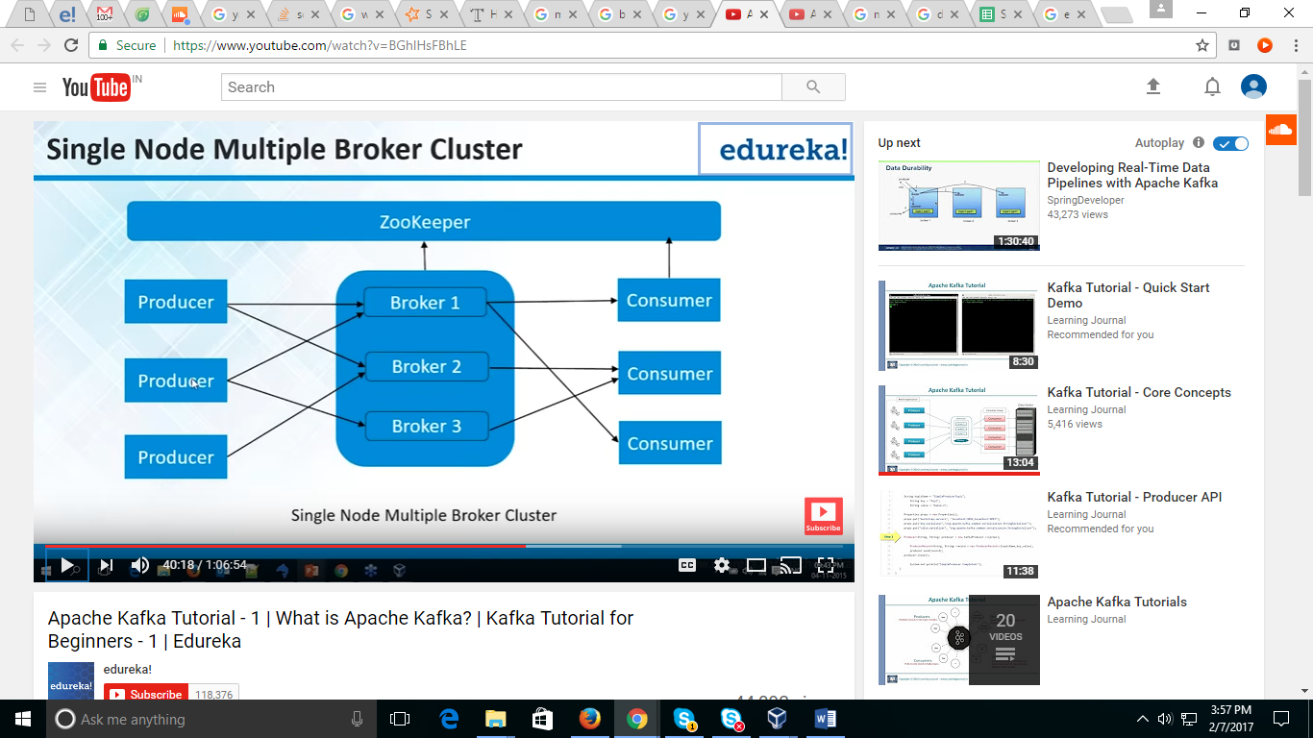

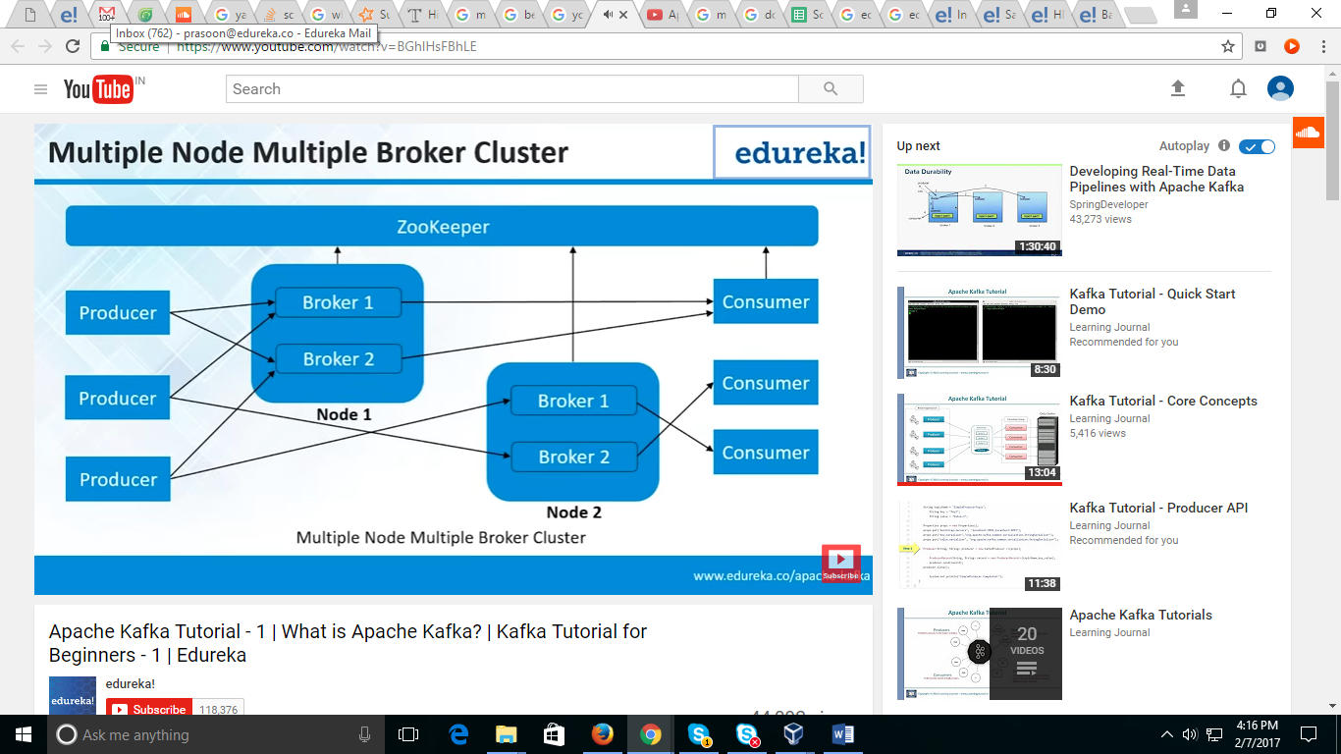

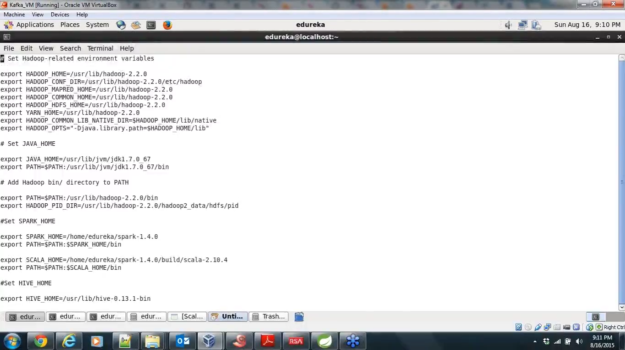

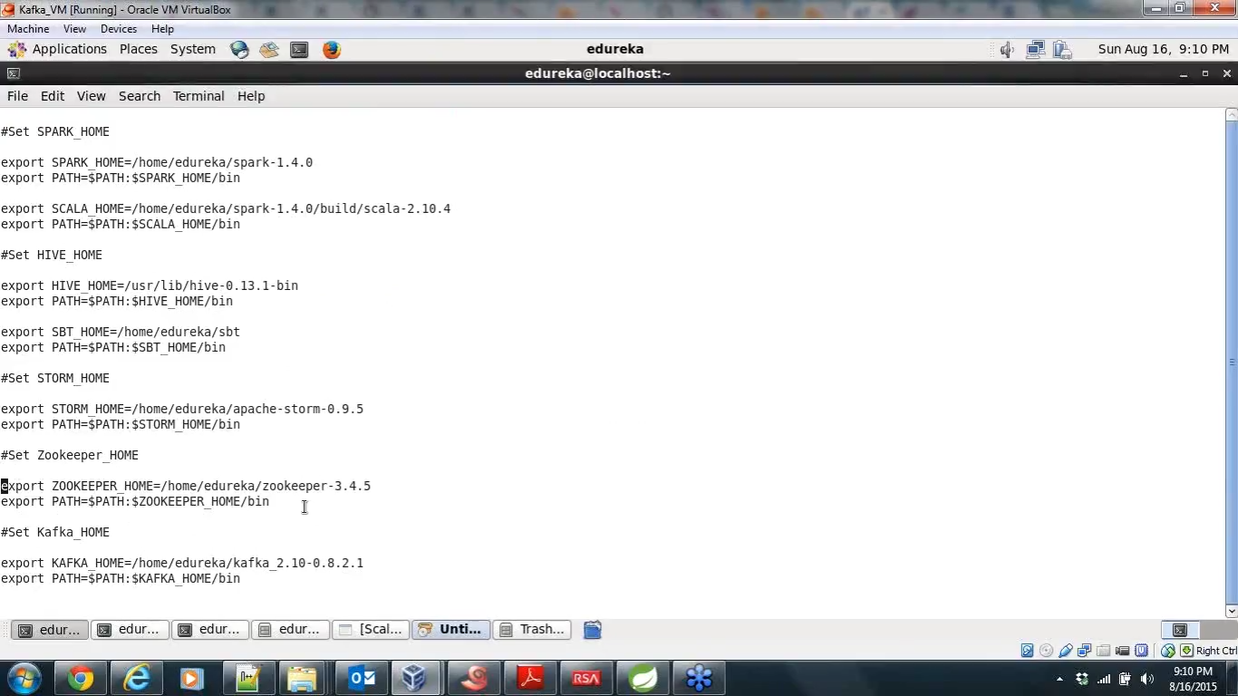

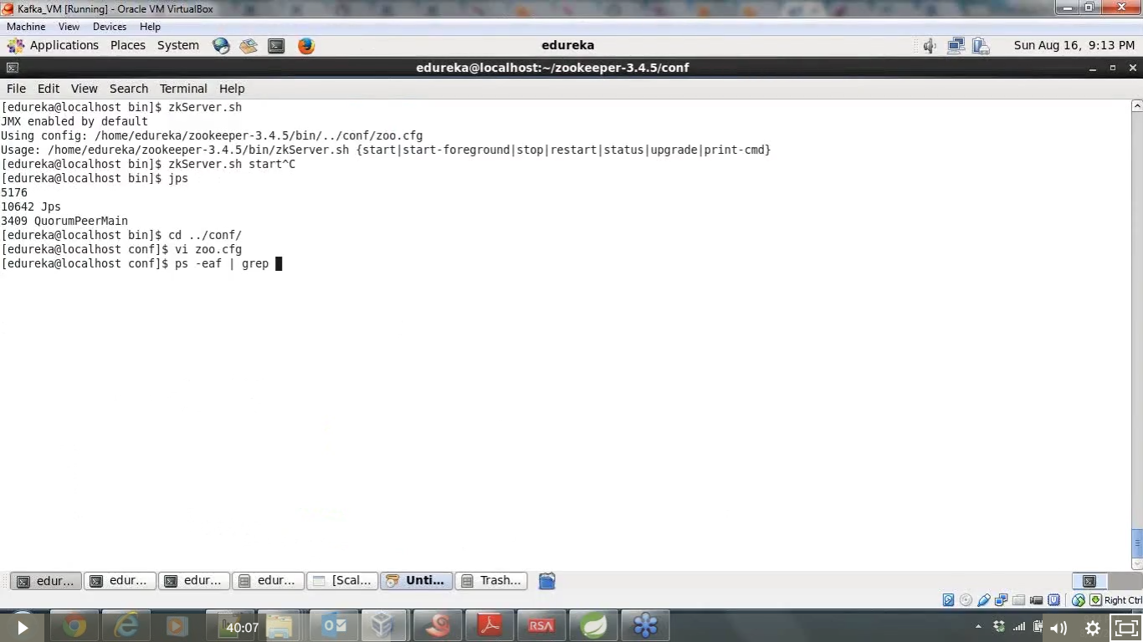

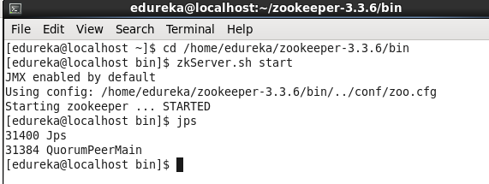

[edureka@localhost ~]$ **cd /home/edureka/zookeeper-3.3.6/bin**

[edureka@localhost bin]$ **zkServer.sh start**

Start zookeeper 🡪then start kafka server

Ps -eaf |grep main

[edureka@localhost kafka_2.10-0.8.2.2]$ **kafka-server-start.sh config/server.properties**

./bin/kafka-server-start.sh config/server.properties

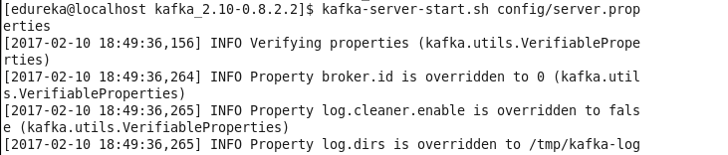

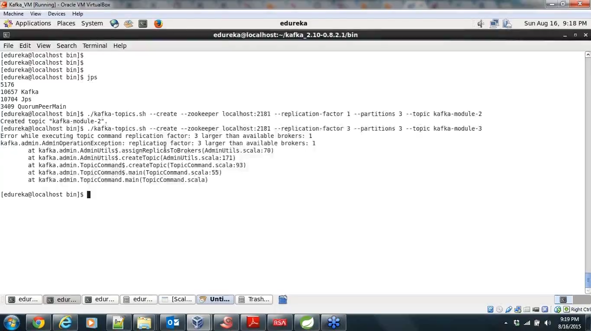

Creating topic

[edureka@localhost bin]$ **kafka-topics.sh --create --zookeeper localhost:2181 --replication-factor 1 --partitions 1 --topic test1**

**To check the topic list --- kafka-topics.sh --list --zookeeper localhost:2181**

bin/kafka-consumer-groups.sh --list --bootstrap-server localhost:9092

bin/kafka-consumer-groups.sh --list --zookeeper localhost:9092

--replication-factor

> **kafka-topics.sh --create --zookeeper localhost:2181 --replication-factor 1 --partition 3 --topic kafka-mod2**

[2017-02-10 19:06:13,774] WARN Connected to an old server; r-o mode will be unavailable (org.apache.zookeeper.ClientCnxnSocket)

Created topic "kafka-mod2".

* **kafka-topics.sh --list --zookeeper localhost:2181**

**logs are in**

**/tmp/kafaka-logs**

**Producer---**

**kafka-console-producer.sh --broker-list localhost.localdomain:9092 --topic kafka-mod2**

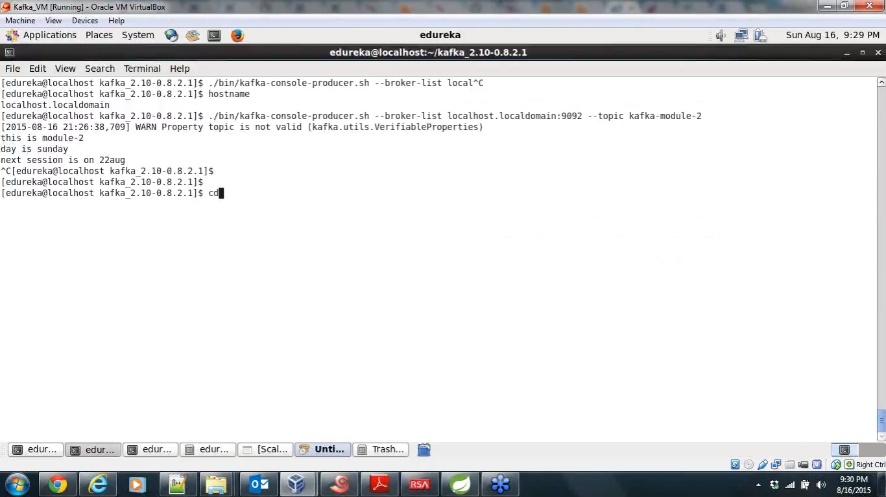

**Consumer --**

**kafka-console-consumer.sh --zookeeper localhost:2181 --topic kafka-mod2 --from-beginning**

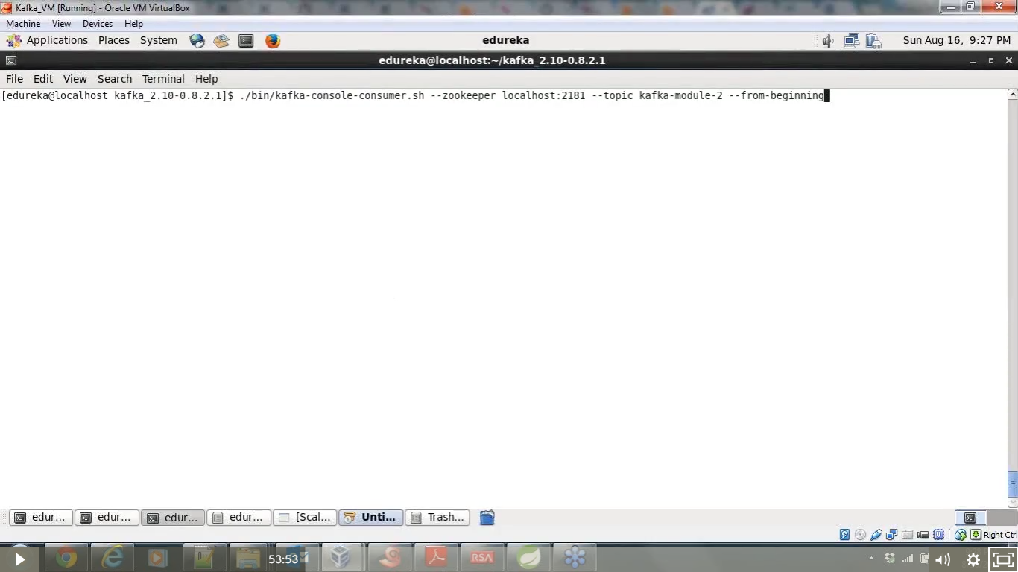

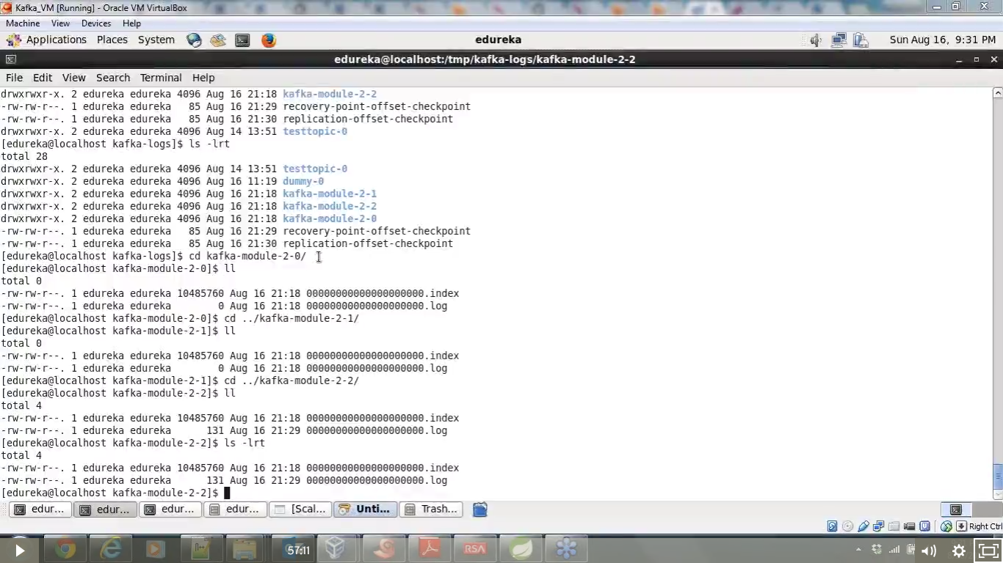

Zookeeper properties – tick time, heart beat, - logfiles -

* Tick time in zookeeper , the time interval in milli second , used to regulate heart beat from the brocker
* If a heart beat is not available from a brocker within this time , then the particular brocker is not available – zookeeper will not go and check availability of brockers

Logs are written in tmp/kafka_logs

Multiple paths can be given ..(according to no of disks available , and create directorities also which will give better performance)

If you are writing a message , it will move to the partition of a topic based on the partition key in the in the producer

How to pass partition key and offset – we will

Only consumer will know the offset values it is managed by consumer instances

Changing ownership

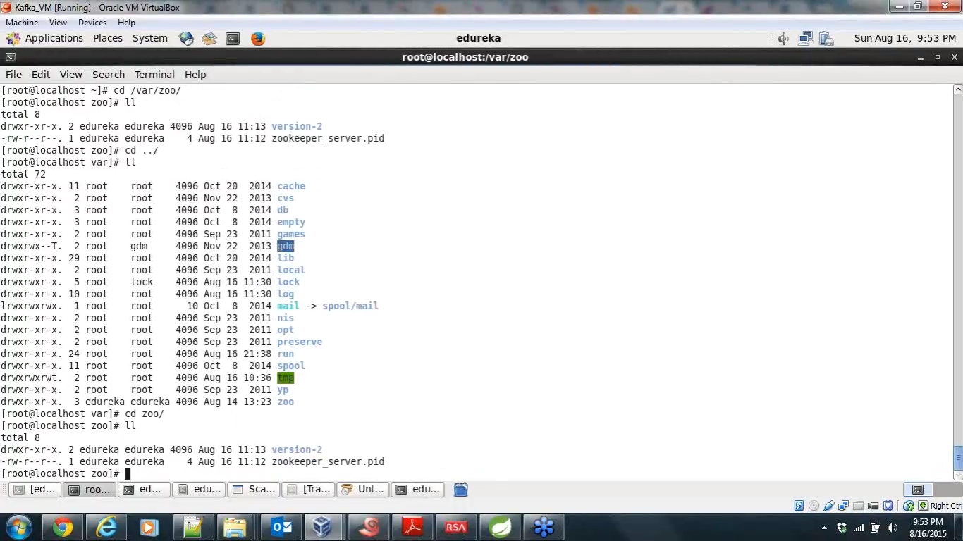

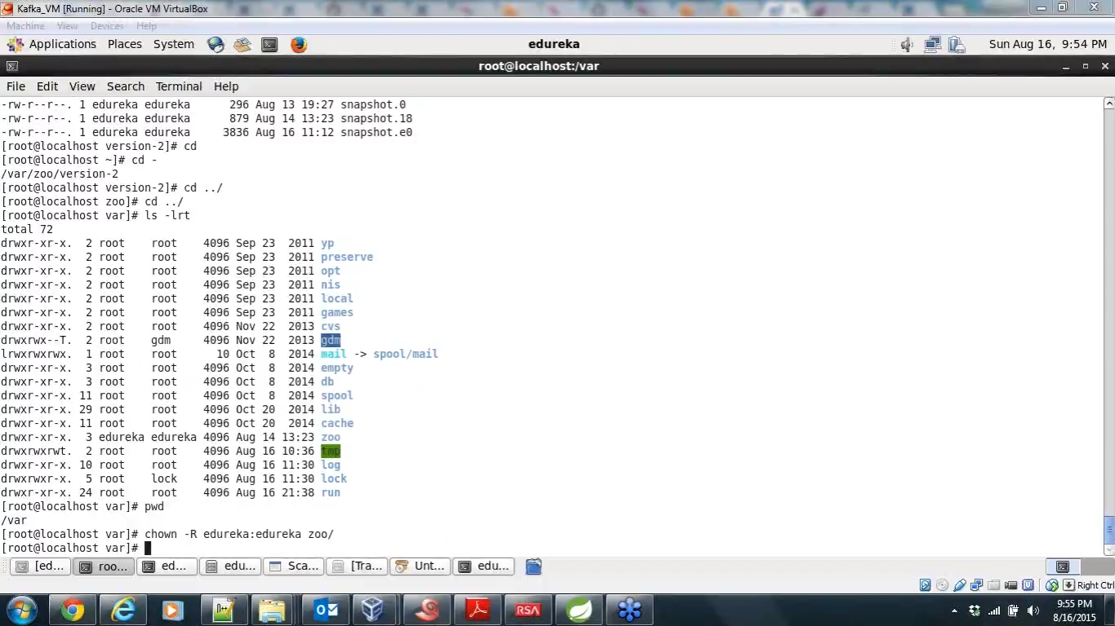

Port number for kafka is 6667 (old version) – now 9092

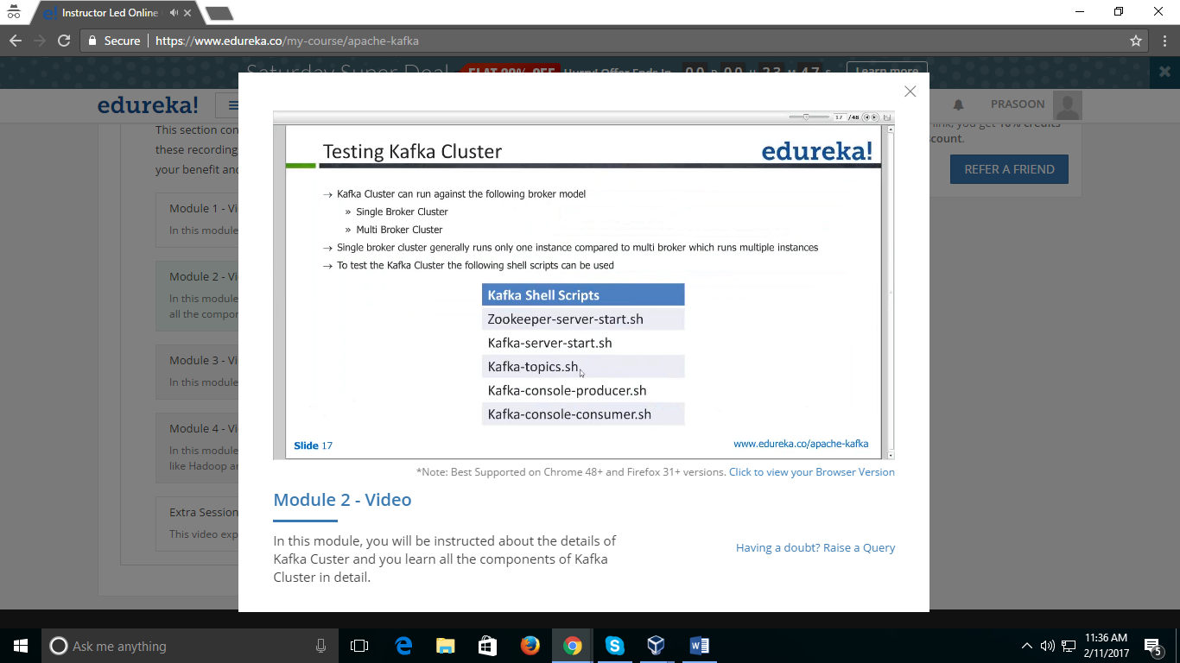

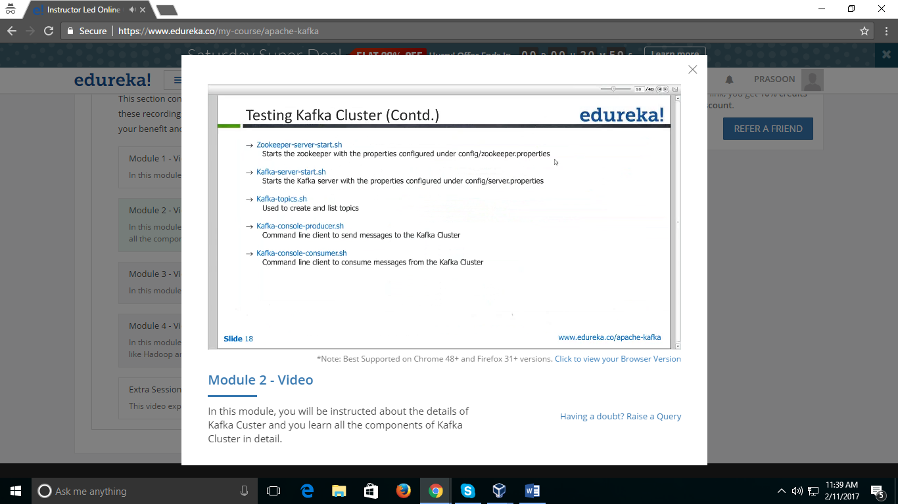

**Kafka clusters - brockers set up in cluster**

**Goto kafaka 🡪 create 3 server properties with different name and copy ….and change the name**

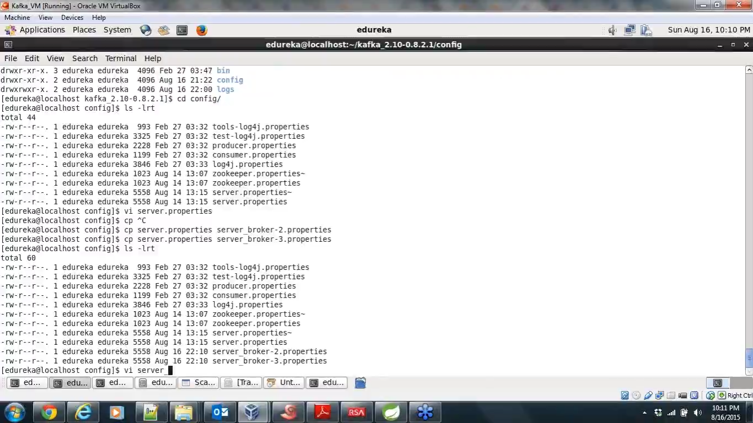

**1. Server.properties bid =0 : port =9093**

**2. Server_broker-2.properties => bid = 1 : port =9093**

**3. Server_broker-3.properties => bid = 2 : port =9094**

**Change brocker id , port number**

**Create directory in home edureka 🡪 brocker logs 🡪 brocker-2 , brocker-3**

**Comment the old log path and give new path for new directory created**

**Start brocker 1 – instance 1 -- [Kafka-server 0]**

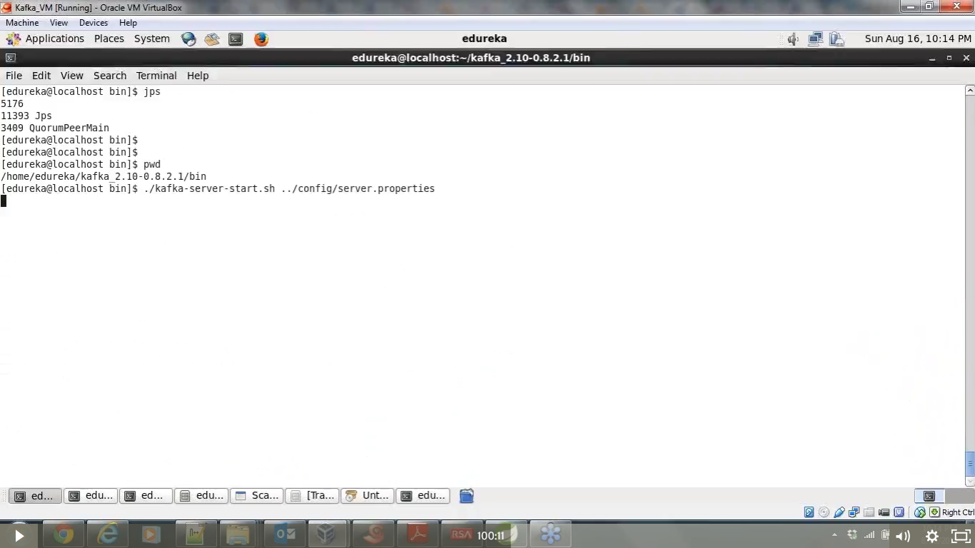

**Open other terminal**

**Start second brocker – instance 2 -- [Kafka-server 1]**

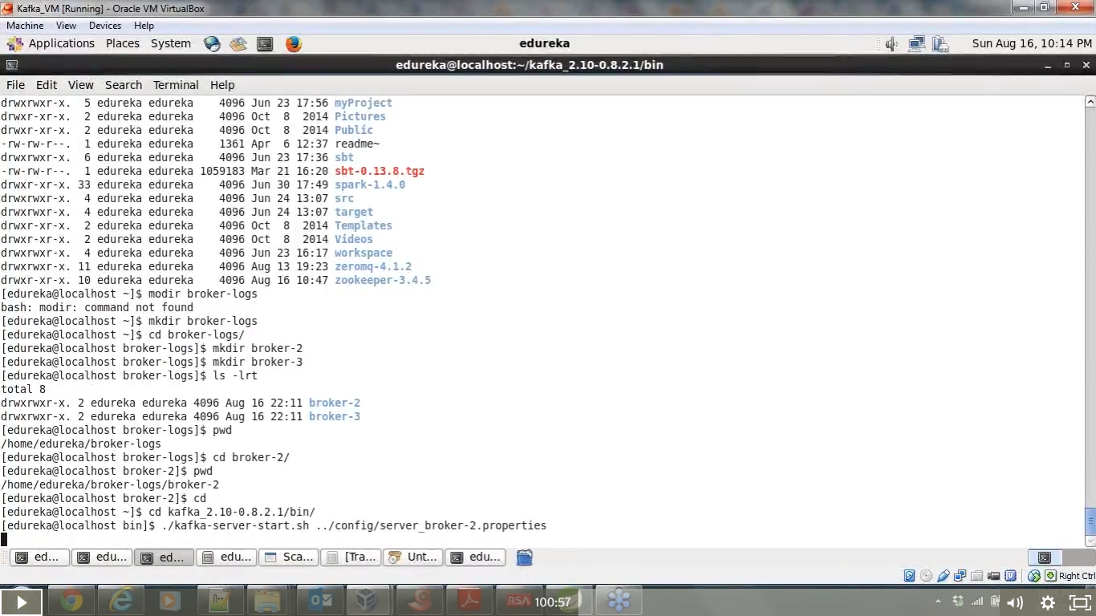

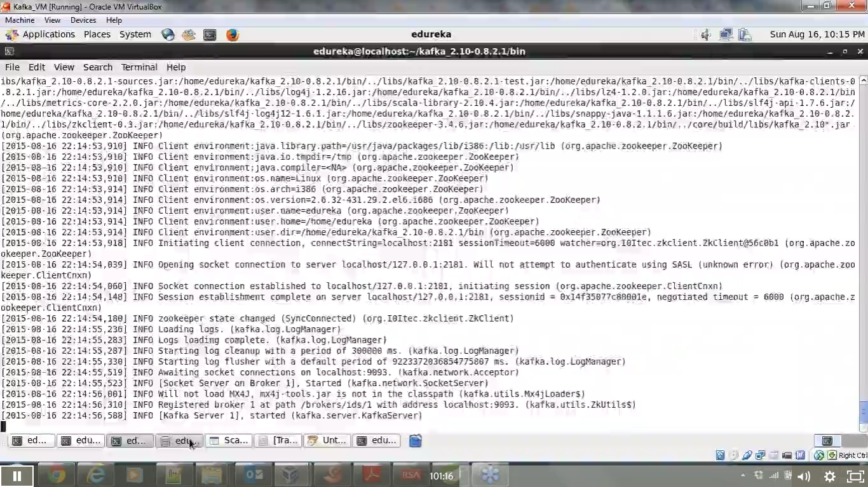

**Start second brocker – instance 3 -- [Kafka-server2]**

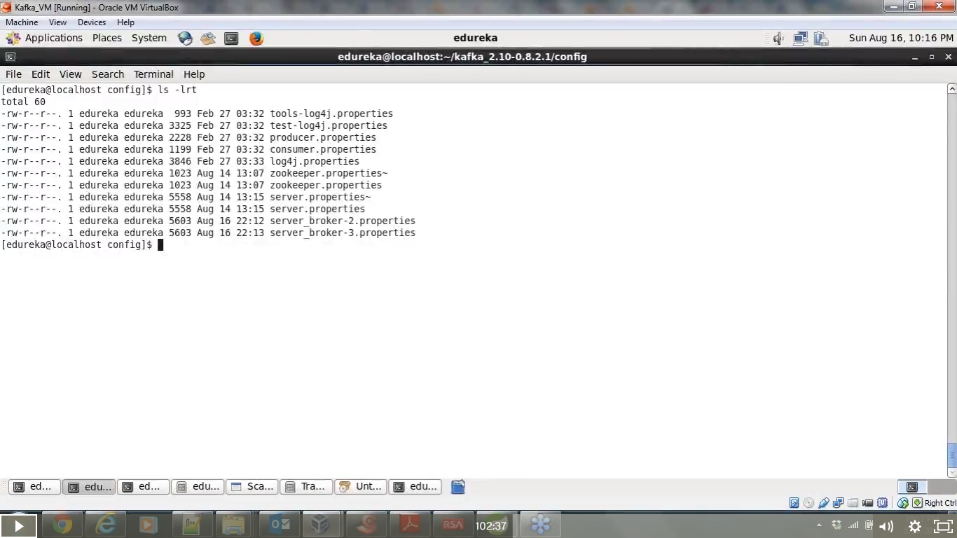

Sudo jps to check – whether all are running…

Create topics …. Now with partition and replication factors

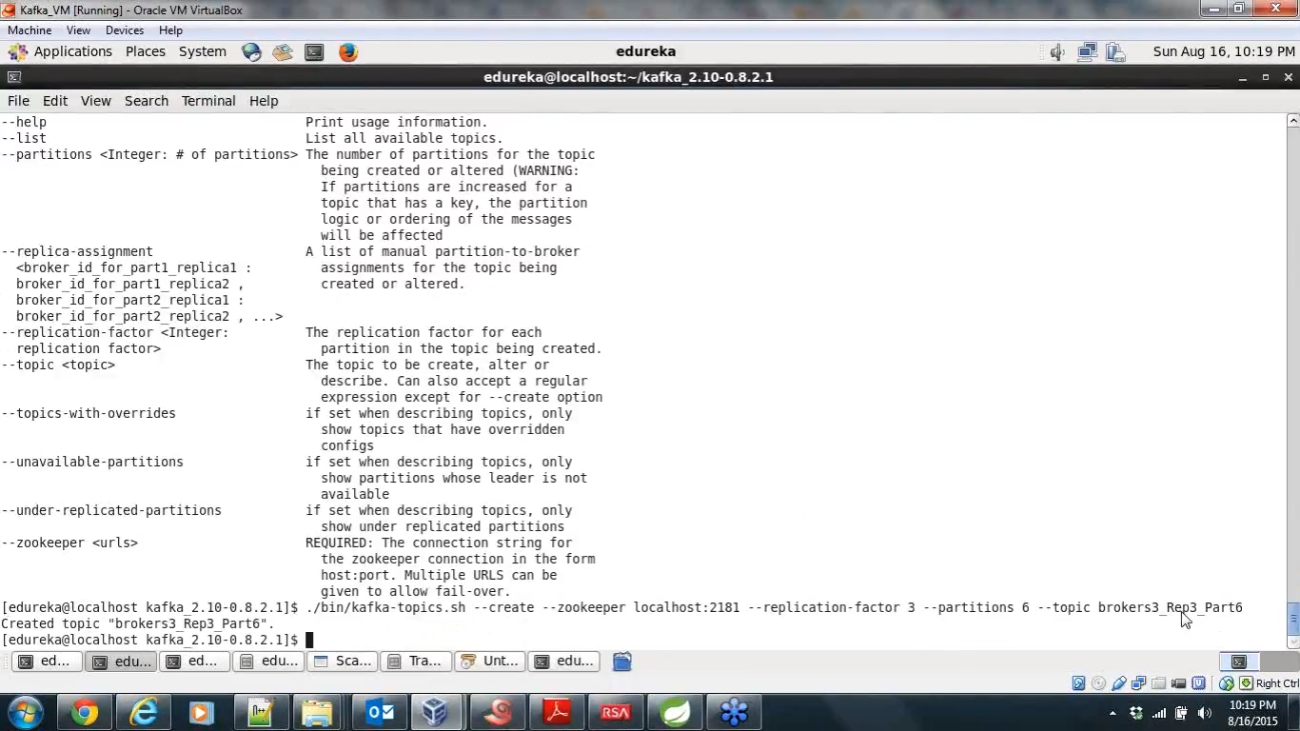

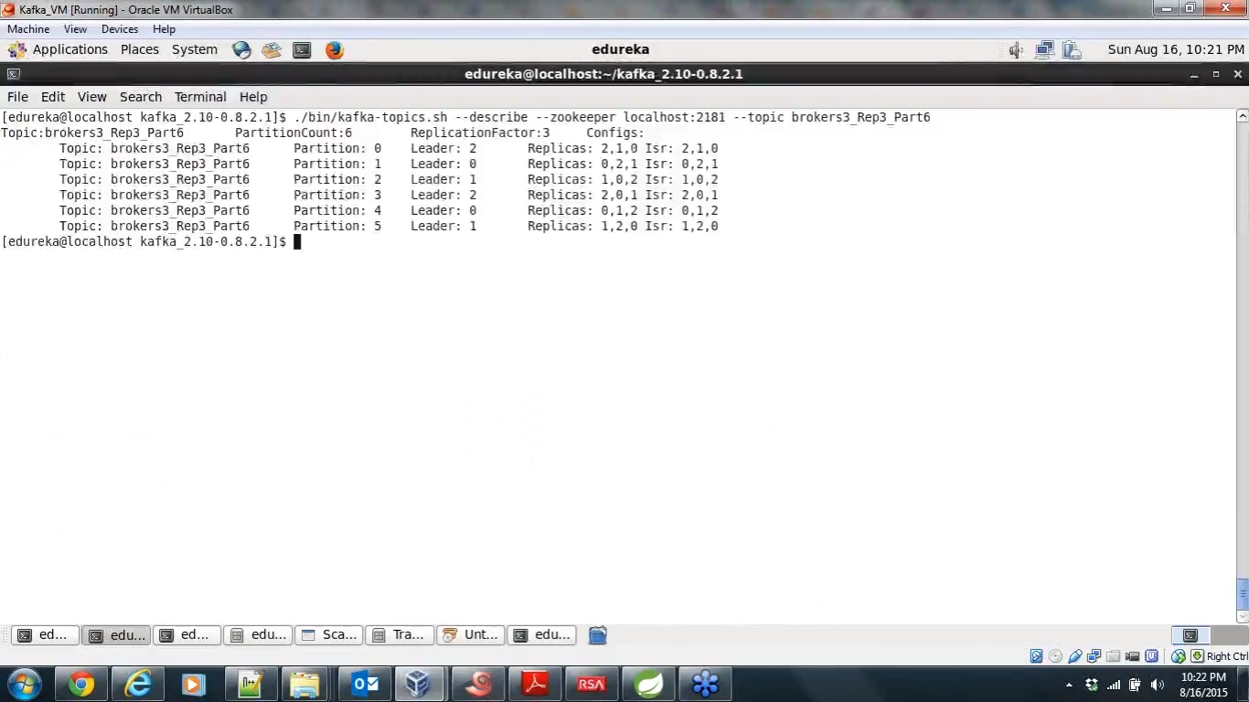

**Isr - insync replicas –**

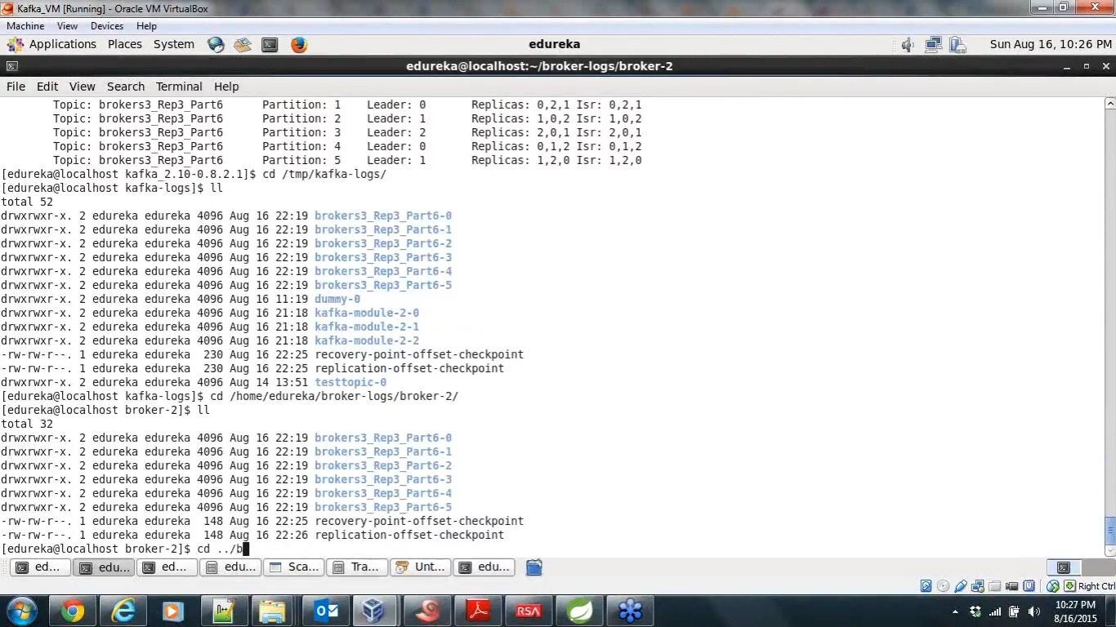

**Now Pushing messages to the topic - -**

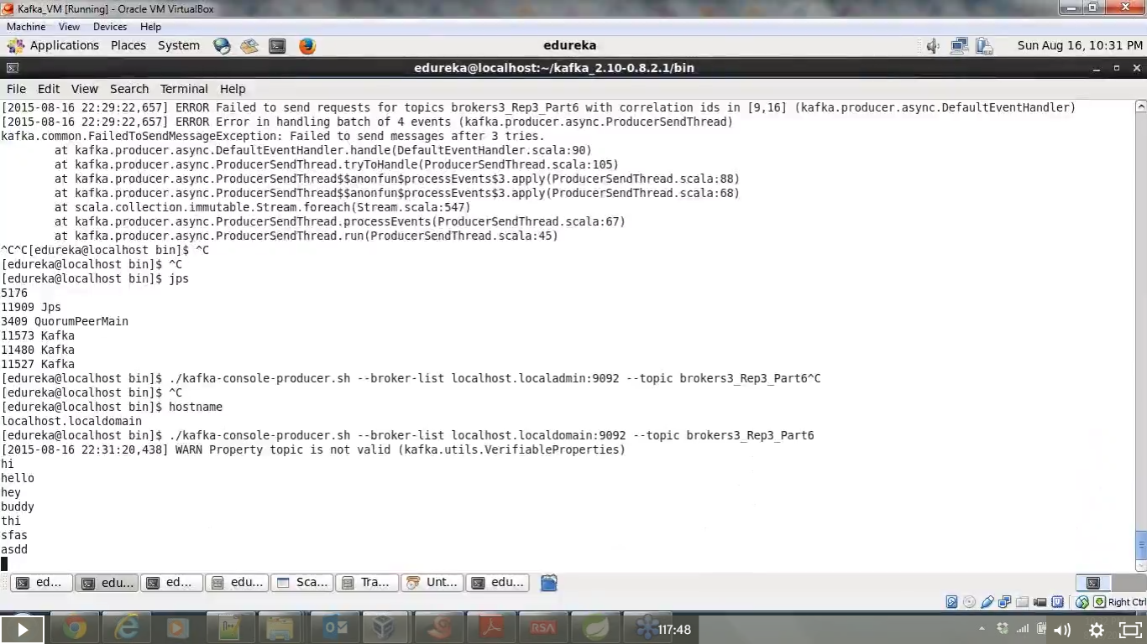

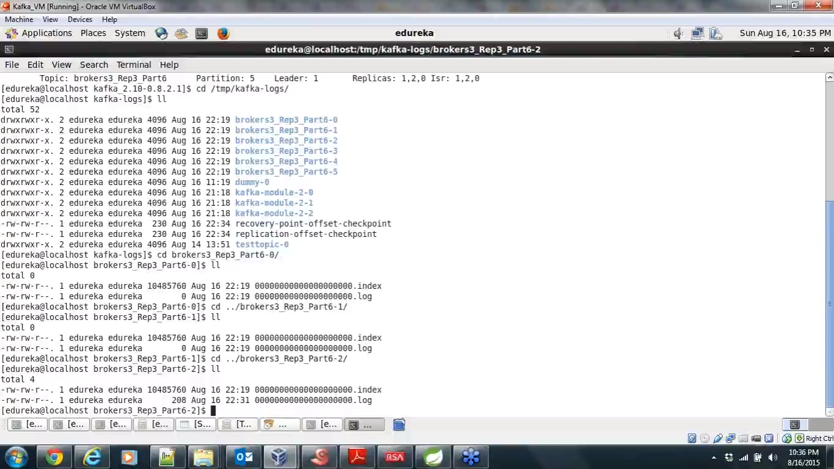



Message is written in partition three -- and the leader is broker 2 [2/[1,2,3]]

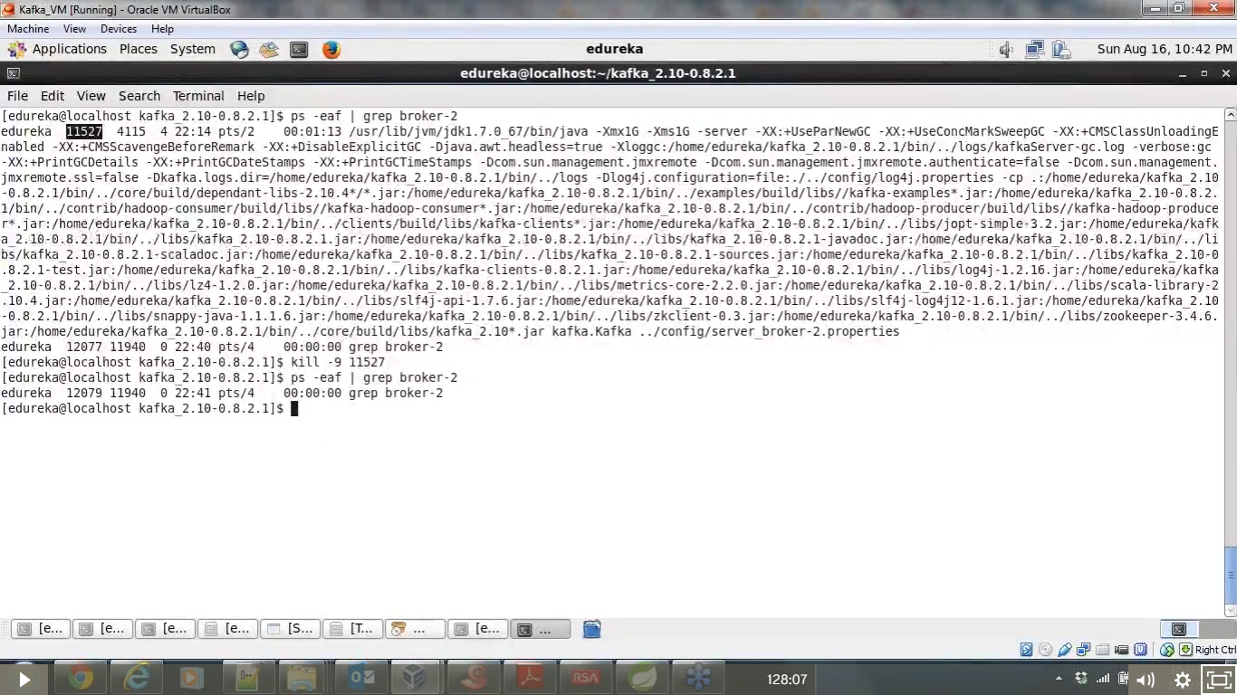

Now process is killed for (broker 2) – and still if we run the consumer – we will receive message as the replica is created in broker1,3

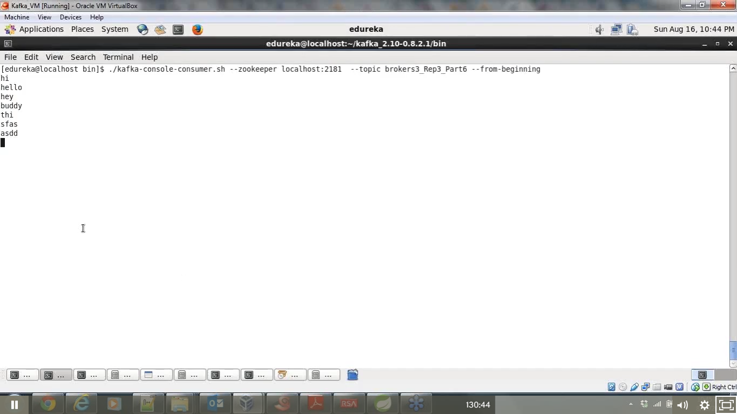

This is how the fault tolerance is achieved…

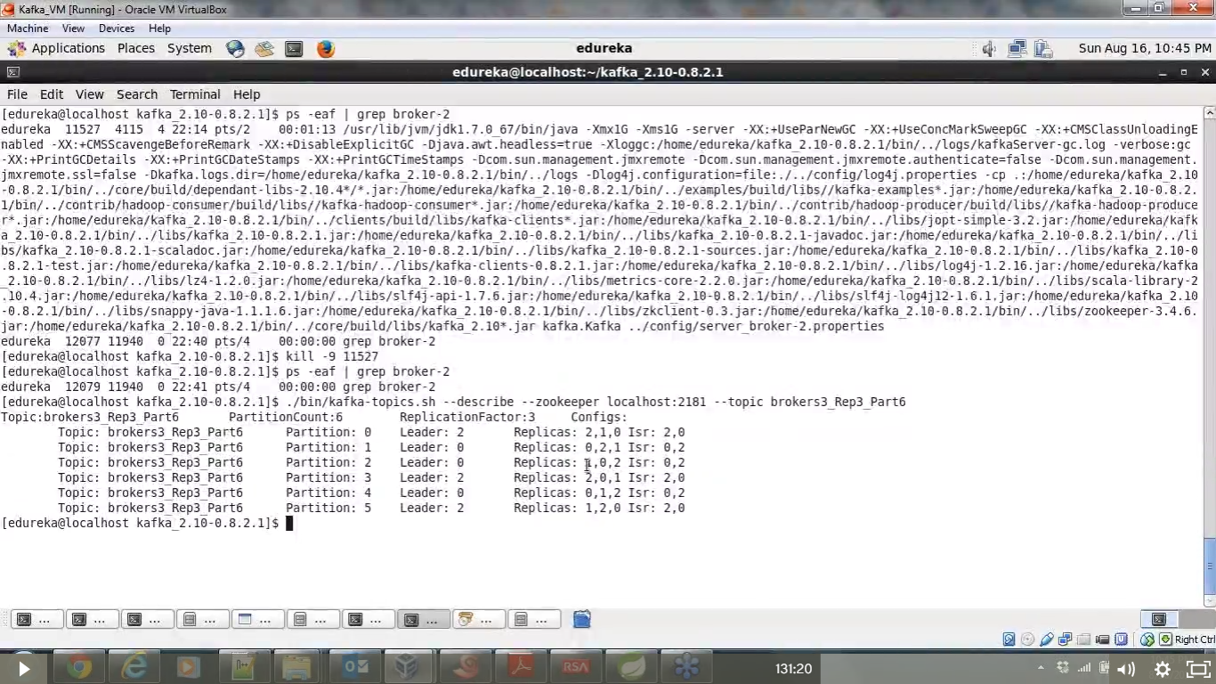

* ---
* Kafka producer API—

Kafka producer – instance to send messages ..

Source code – with multiple packages …

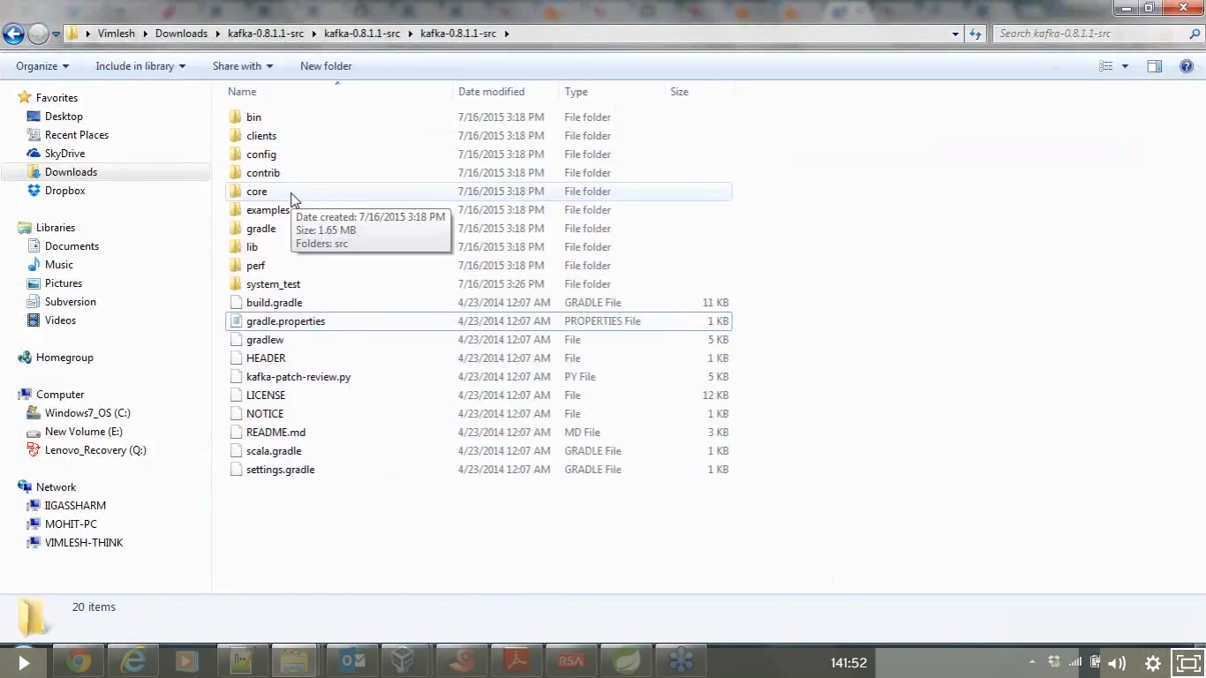

In kafka bin – producer.sh

Kafka-console .producer.sh

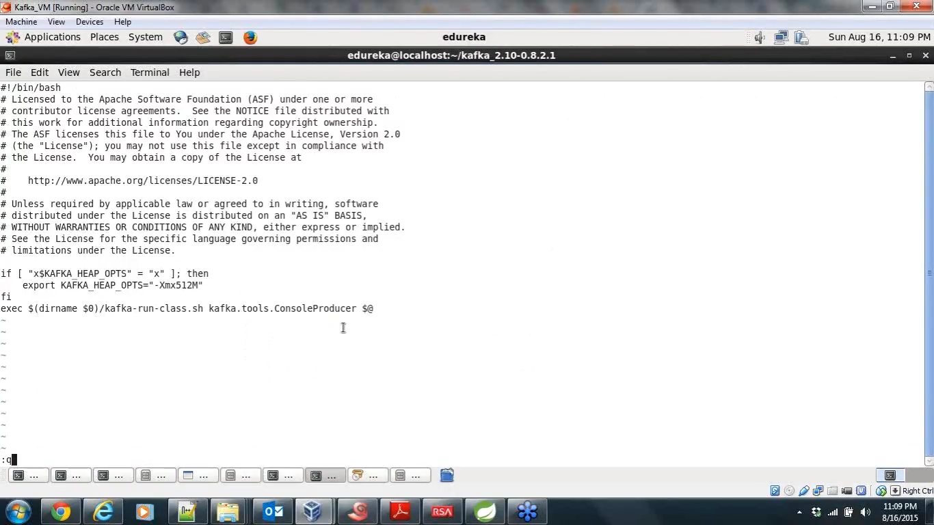

Console producer program

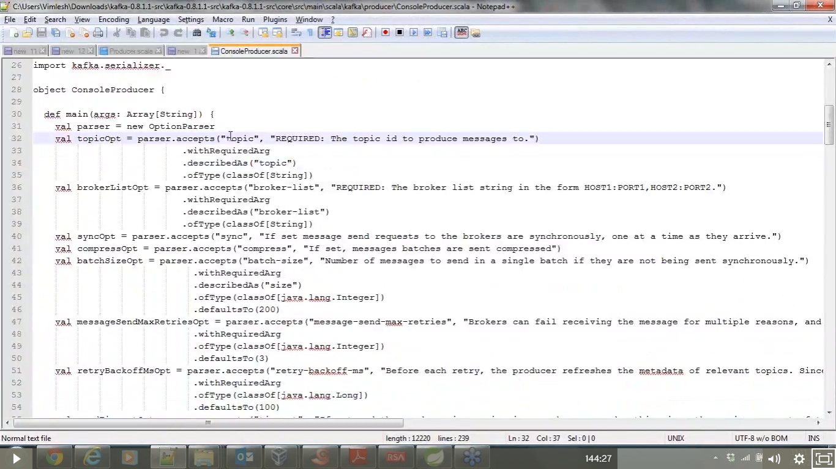

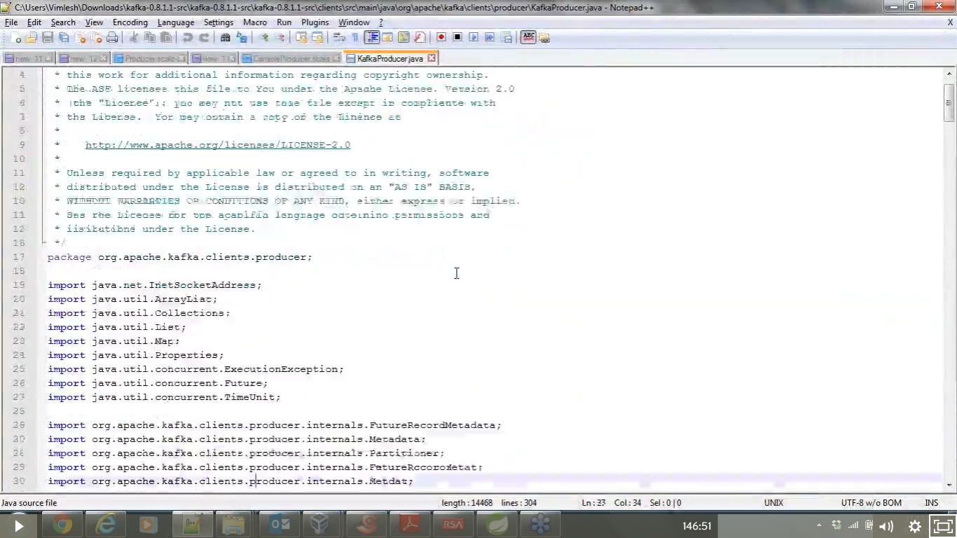

Property files are passed , as part of map – while creating the instance of the producer – these property should be passed..

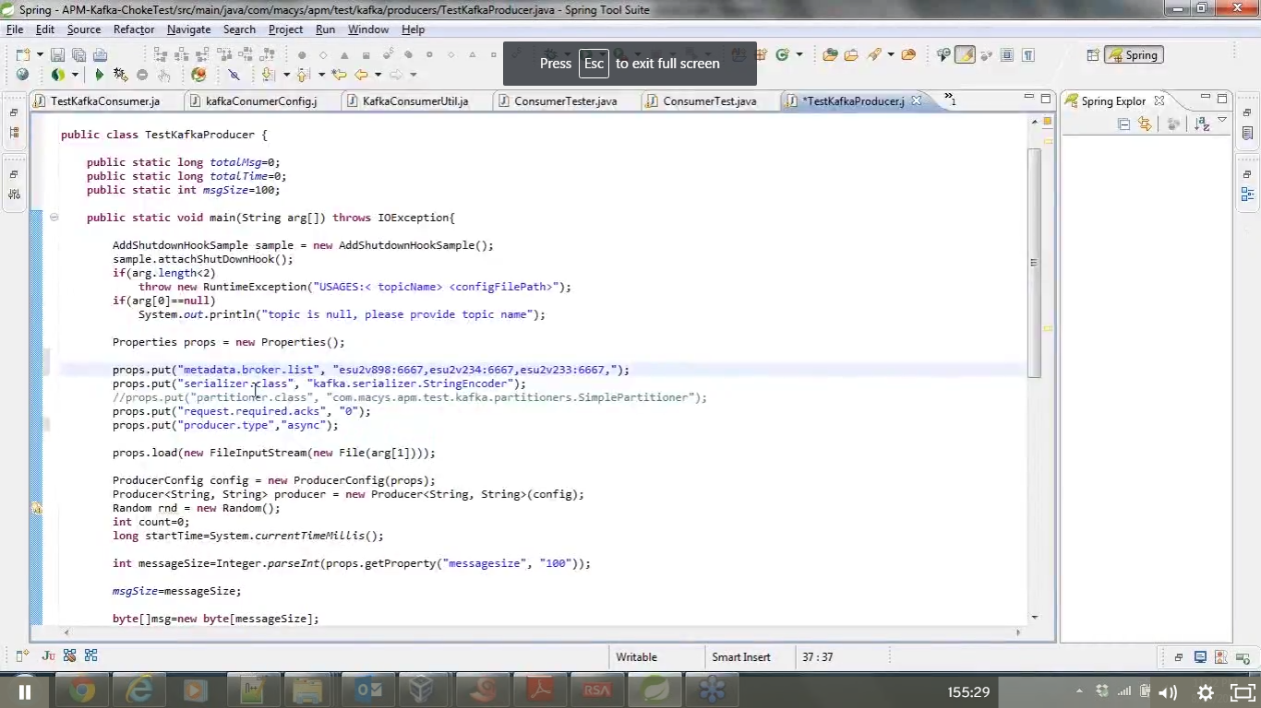

Important properties required for the producer

1. metedata brockerlist(8.1.1) in in (8.2.1)it is brocker list
2. serializer .class
3. Partititoner class key -- for equal distribution of messages to partitions

By default if partitioner key is not passing then it will keep on write to single partition log for som minutes nad then write to another partition

By default there are partitioners , or we can write our own partitioners also , to kreate akey with unique hash code

1. Async type or sync type

Proprties can be defined in some config files and can be run dynamically during the run time

All properties shld be in a conf file and , if we are using producer in flume - when we are passing flume code pass the config in the path , instred of hard coding – can be loaded by using arguments -- during runtime

-- **arg0 -topic name ,-- arg1- config file**

**Property file will be pushed to producer config --**

**[[create producer config to read properties ]]**

**Create producer instance – initializing**

* **Developing partitioner**

**Created random number passed in list [0-255]**

**It will give unique number unless t repeats**

**Taking message size from the properties and taking – message size – influences the through put --**

**This is used here to measure the performance**

**--partitionkey is “dummy” here**

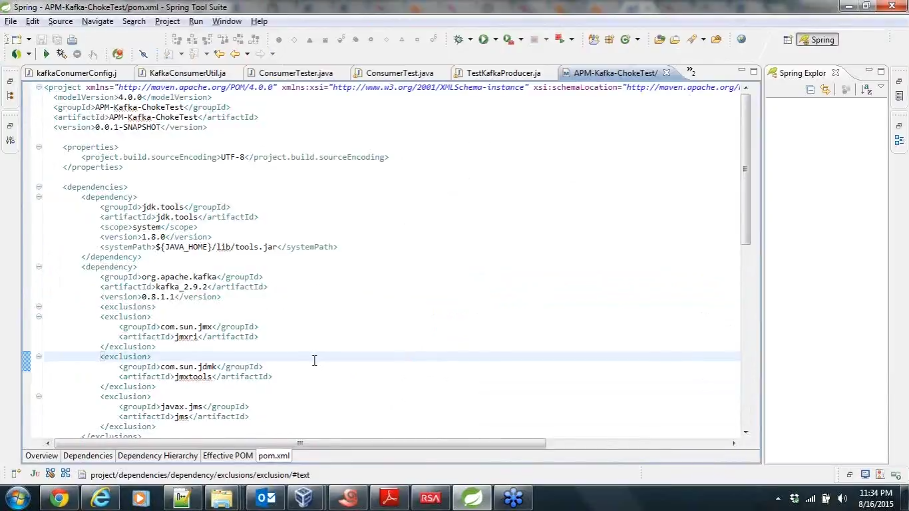

Building this will create the jar, this should be imported to kafka workspace

We have prd.properties also in workspace

These are producer.properties

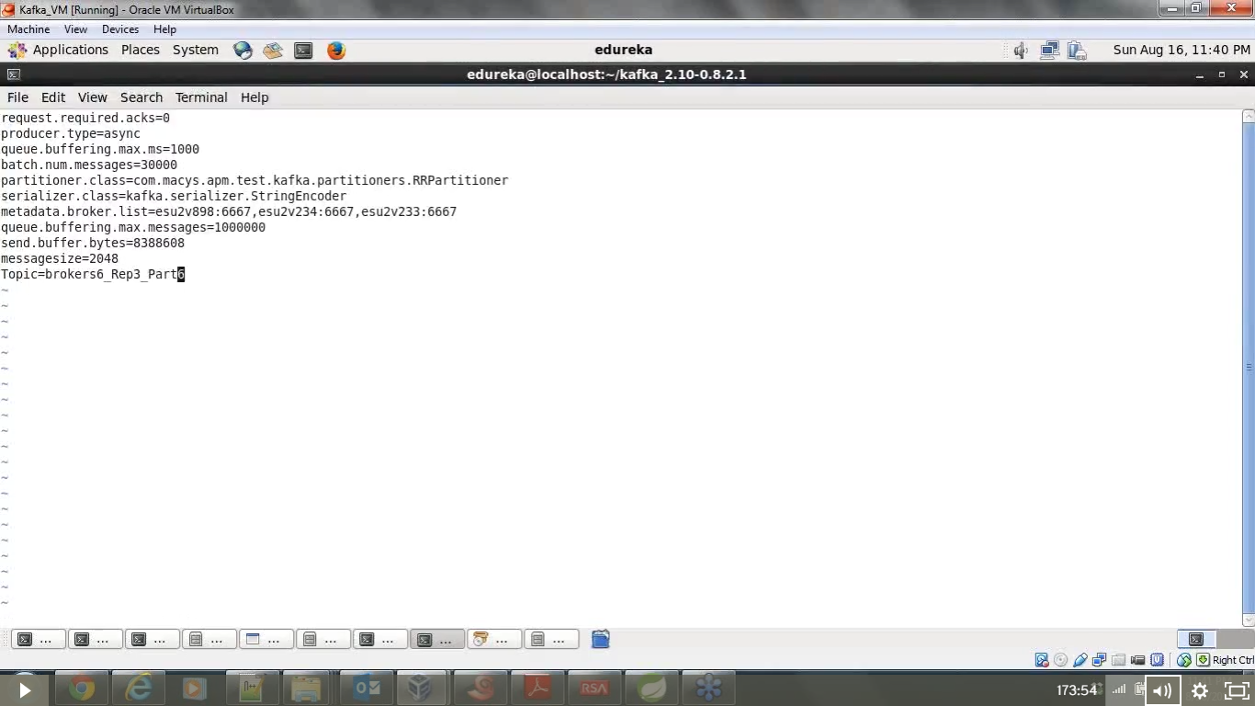

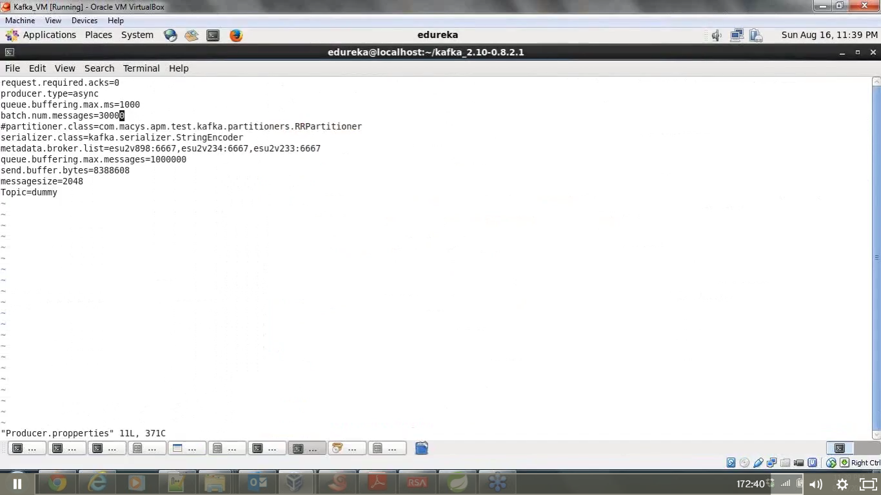

Type is async – no acknowledgement for the send messages

Message queue max—

Consumer properties --w r t kafka - 8.1.2

Group id -decides which queue model we are working -

Zookeeper. Properties

Consumer id

Fetch.messages.maxbytes-this should be set same as set in the producer ,

Consumers fetch –

Maven- build tool – handles dependency – per consumer group

Pom file will handle dependency –

--- adds to less amnual work in case of changes of the versions..

It will downloads all required jars …

Artifacts ids should be mentioned in the pom file

Can handle build number ,control jars.,control binary bit dependency etc…;

Maven has multiple goals - for jar file of web archive , entreprise archive ,.. (inastallation or any thing or clean the project etc – it suppots all kinds of goals)

Mavenrepository.com -

All the jar file and configure your project and download any kind of jar file and clean your project

* It has online and offline repo

In ECLIPSE – MAVEN PLUGIN can be added

--instead of java project – create a maven project - -

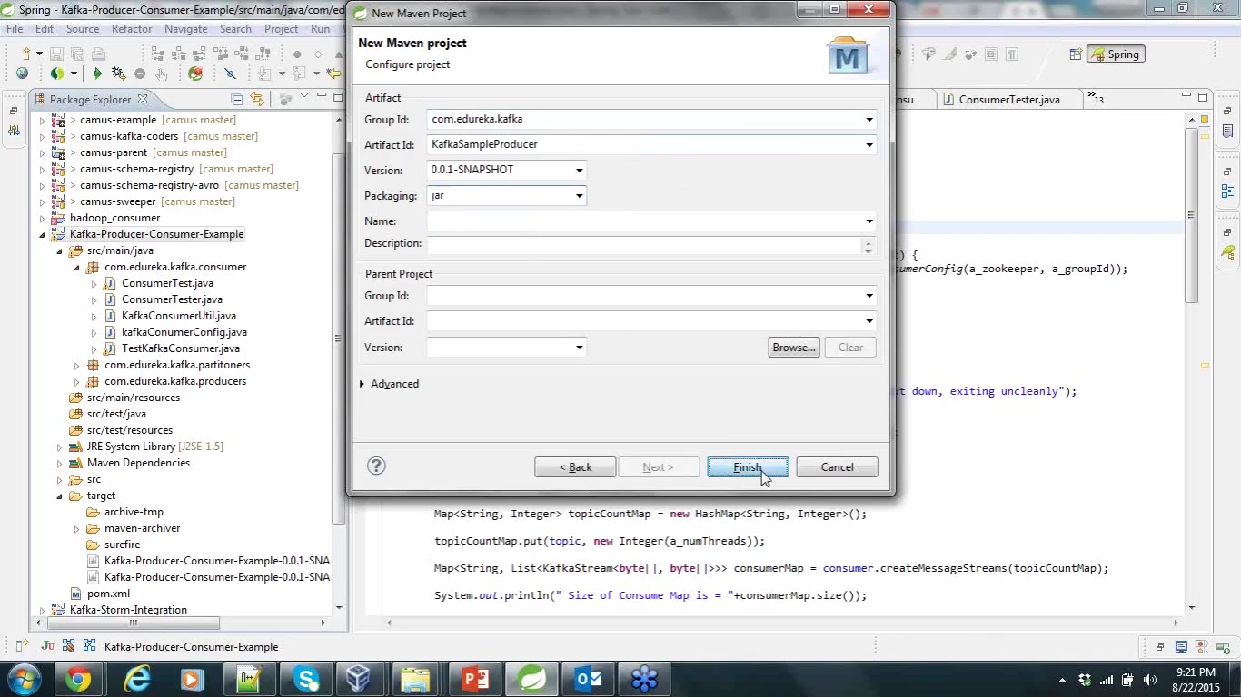

In case of other ide and plugin , maven can be installed directly to the system

--download it 🡪 un tar it 🡪set home path and class path

To verify – in users .me directory will be there 🡪 repository will be available 🡪 will have all jars 🡪available jars are used from here other than downloading

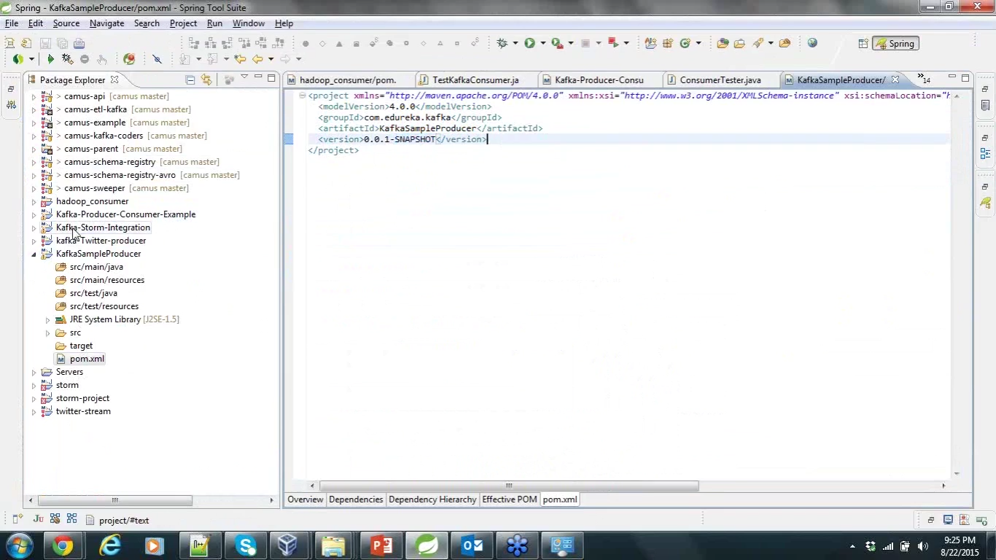

Group id – package name

Artifact id -- class name

These are by default dependency part will come after this ..ie jdk path for compilation –

Kafka

When dependencies are added and saved – all the jars will be automatically added in the maven dependency directory

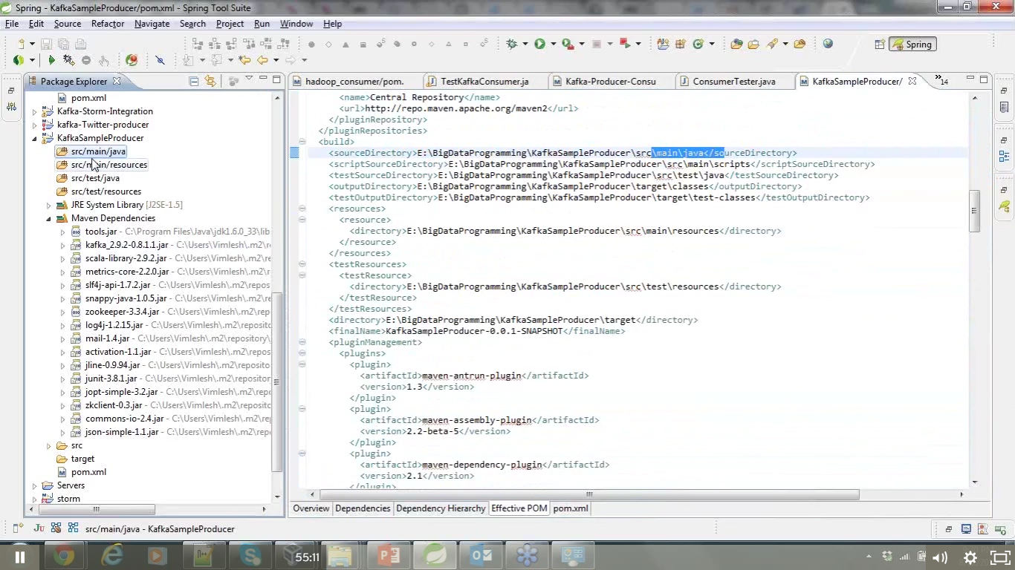

Consumers –

Apps to consume message –

**3 types of consumer –**

* High level
* Simple
* Hadoop consumer API --

Can build our own app – with varities (diff api’s - 3 consumer [**high level consumer** 🡪 it maintains the offsets by itself

**simple consumer** 🡪 as per the programing needs , this has to be controlled --offset needs to be handled here – they will commit the offset to zookeeper or Hdfs and they can start reading the message from the particular offset – complete coordination of the offset should be managed by ourselves

])

Hadoop api – linked in is using this api for consumers –linked in will take click streams and messages ,logs 🡪all are coming to kafka 🡪then they are running map reduce codes from the kafka and process and put it in the hdfs. Here map only job is there no reducer code

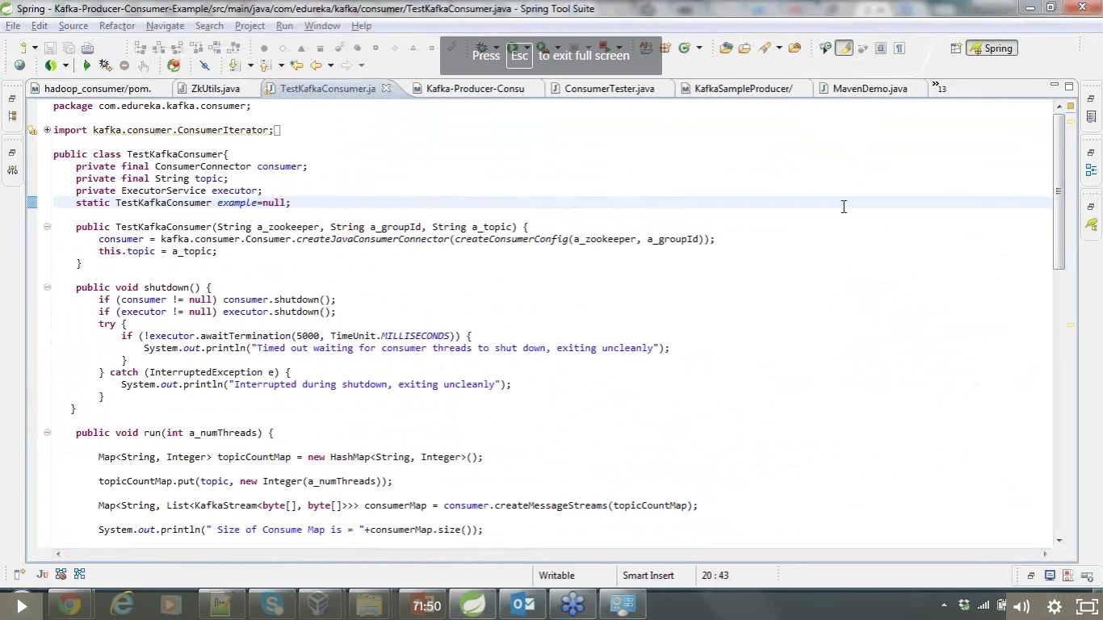

This is example for high level consumer - -

In storm we will see the simple level consumer

Add shut down hookup is related to the closing - ctr+c 🡪 we want to give the no of messages consumed and total time taken for the same

Property -consumer configuration – zookeeper what zk , group id ,topic name from which we are going to fetch the messages , no of consumer **threads** required for consuming the messages..(simple one thread or multi thread can be done )

When consumer tries to connect to kafka brocker connector is required create java consumer connect is the configuration required to connect to zookeeper and brocker

Consumer config

Zookeeper .connect, group id

For high level consumer api we will start adding

Consumer map will get the message

In run method – no of threads and, get will start reading from the specific topic –

Get will start reading the messages, it will be I form of streams- we will be reading with the help of file size, if we have file size we can get single file also ,multiple file(records) also once we have the record them messages can be read one by one all messages streams-

All three types of consumer works in different way

Consumer config can be passes as hard coded or dynamicly from a config file and pass this config as input to the java connector

In config we need to give

zookeeper address

group id

Topic name

Incase if we are using multiple thread – its details

Other configs susch as max file size - Increase time out of some other paramerters – max fetch size .. any parameter in kafka documentaion can be passed

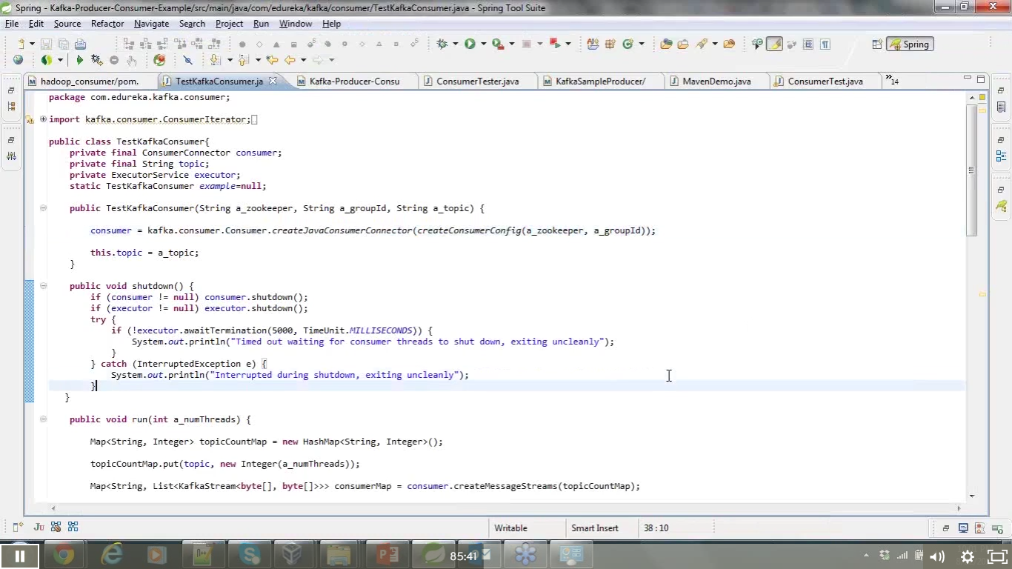

Once kafka connector is ready

Next step is to create consumer map messages frame

Consumer message streams map(topic name, no of threads)- how many threads need to start the topic

--next step consumer map will have kafka stream value one is string other is the value is stream map will get topic and list of messages

Then getting list of messages in map 2 in second step

Then iterate over the list - with iteration we can acces single messages and start printing those messages,

In case of multiple topics with multiple threads , you can use thos e messages and start printing those messages

In comparison with producer config

Both will look for some kind of map with property file with all needed configs

Once consumer connector is ready with configs - in producer instance, we need to produce keyed message with topic and partition key and last history of the message

When consumer connector is ready in consumer – we need to create the message streams which will have topic name and stream

Producer will send the keyed message, here you have the map and will iterate over the stream

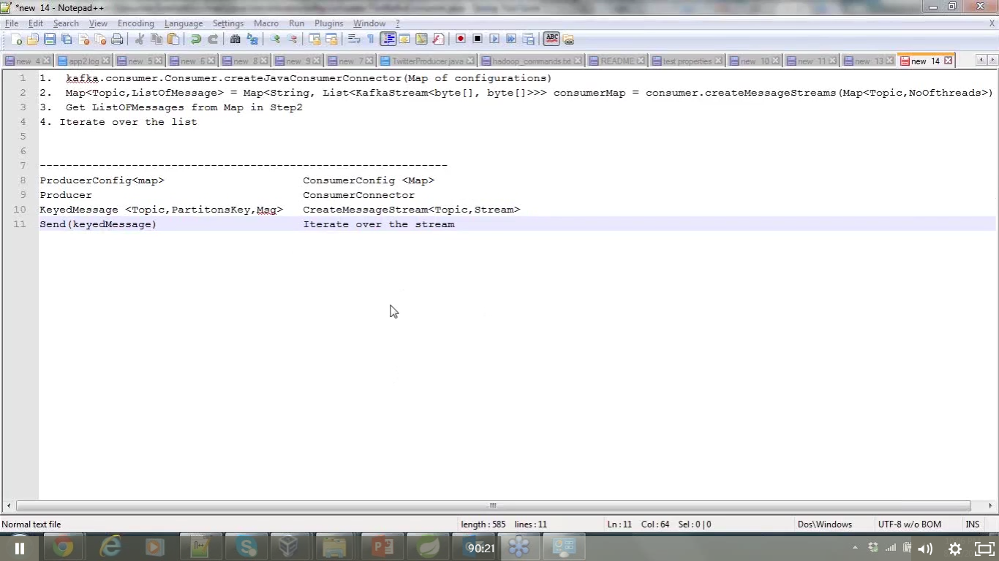

How we can see partition information in client

In case of producer – its always up to us ,what key you are passing

In consumer there is no key – it will have one tread one partition , one thread is also decided by the consumer no you /us - that is called balancing for the broker –

Demo --

Hadoop portions

Hadoop consumer api – communicating with hdfs

Data from kafka can be given to mapper program as i/p and data can be run in form of key value pair, to particular hdfs location where ever you want, if data is coming at high speed , then batches of data can be clubbed into the mapper itself and data can be written to hdfs

Camus – written all classes required are written - kafkas – hdfs pipeline – perform mapreduce jobs – distributes loads out of kafka and can be used to develop kafka consumers

Real time data streaming pipeline - data is produced in some path and there need to push the data to some processing engine to some persistant storagre or pipeline

For creating data pipeline—

Hdfs to kafka 🡪camus api can be used (Hadoop consumer api)

Gobblin is a replacement to camus – if you are going for ETL work load , this is replacement of camus

Vimlesh m3

Configuring custom producer -project:--

**Producer-**

* Instance of producer config
* Instance of kafka producer
* Producer record – by providing the actual message
* Send record or records

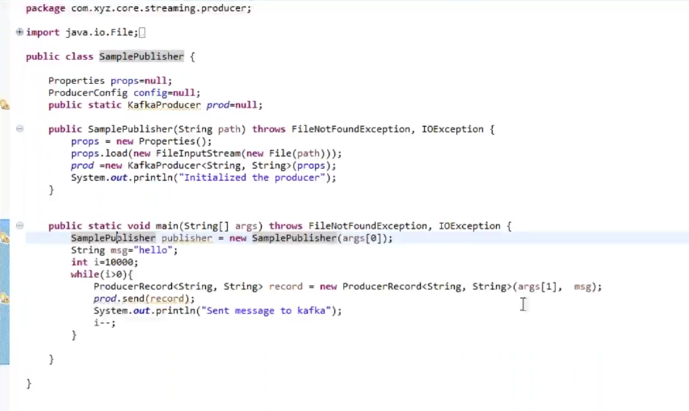

In main function – sample publisher arguments are producer properties path

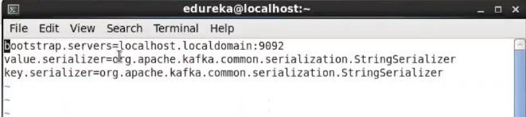

When property is passes , this will be automatically loaded to a map - map is called as properties

Properties extends hash table and it implements map 🡪 every node is an entry , properties will load from the file path – gets the properties and creates the instance of props

In next step kafka producer is getting created and passing the props to it - kafaka producer is creating an instance of producer config and it is passing all the properties directly to it

Producer config – configuration setted will be going to validate all the configurations , config value will be compared and checked with original and throw error if the value given is wrong

Serializer and deserializer

Bite array -- Jason file -

How many to serialize and deserialize - when – size differs --

It takes whole message and serialize it

Reading message from file –

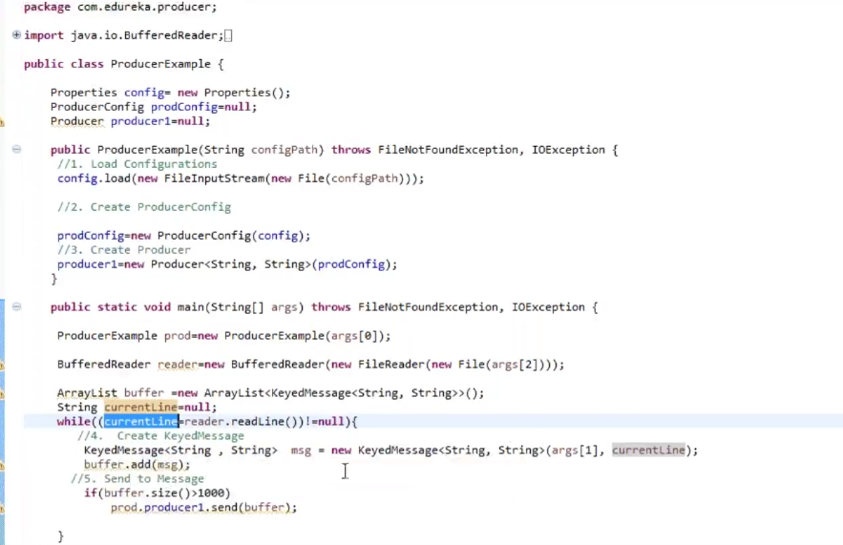

Reading from file , not hardcoding the message

Keyed message—for the old kafka

and producer record for the new kafka

Hard coded message –

Created jar using the producer code – maven clean maven install

Take the jar file run the jar file

**Consumer --**

in 0.8.2. and 9.2

3 consumers -

simple ,

high level, - offset

Hadoop – no used –much used as – kafka used with Hadoop for apis

* Instance of consumer config
* Instance of kafka consumer
* Suscribe for topic
* Poll the topics
* Process the data
* Commit data
* Handling the failures

Kafka consumer rebalancing using the - the last committed offset

Web app to kafka

Find source , from where to consume the data - write producer to publish data to kafka –

Iot app/twitter /normal application

Adobe click stream – consume data from their data bases for a specific website – measuring click streams

Consuming data from the twitter - use twitter api—to consume data from twitter application..

--source of application changes – uses its own api

Next data or from last offset data will be saved to memory than in disk & sequentially accessed.

Kafka can run on commodity hard ware -- needs more ram for page cashing in case of huge size of messages in millions and billions

Issues monitoring

* Lag in messages – difference in messages - time - produce 10000 message an able to consume 9000 messages - - 1000 message in 1 sec and – for hours it will be a prob

Reason behind lag – zookeeper connection - isueue

Or connection with kafka broker

Consumer code – delay

Huge loads – gc – will more - have to increase ram size if gc issue is happening

Consumer design and flow - design of consumer code—

Jmx matrix from the kafka servers can be extracted to monitor –

--

Kafka – camus - is approach to connect kafka with hdfs/Hadoop – 0.8.2.1

With versions 9.1 and 10.1 - kafka connect is popular feature one used to connect kafka with hdfs => hdfs kafka connect -- >

In camus – scheduling multiple jobs for multiple partitions for – mapper tasks – 10 partitions 10 mapper tasks

Mapper task will start copying the partition logfiles and that partition log files , it will start copiying data to hdfs , - it will maintains the offset which ever data has been copied and this job was scheduled after every hour and – kind of serialization , encoding, req format to dump into hdfs – all those things will be handled -

Kafka connect will do simple programing –

Multiple zookeepers - its just shares the data - and is use to avoid failovers

3 node is in general – and if any of the zookeeper fails – it will be automatically sync up/

**Storm**

**Distributed reliable Fault tolerant system – for stream processing**

**Storm – 3 components**

**Nimbus node – like resource manager - starts worker node -- the controller**

**Zookeeper nodes – co ordinates**

**Supervisor nodes**

**When more tasks are coming – it can be divided and – keep the resources engaged**

**-spout -> (passess data) placement of mappers - it will read data from the input source ..and send it to bolts which will process data . multiple chained bolts .. multiple bolts or chained bolts .**

**First bolt will have one logic ex for making the array of bolts**

**Second bolt can create the hash map of all the words – key will be word and value will be the count**

**This will be network or topology .. out put opf one bolt is the input to the next bol;t in the topology and the last bolt will be string or persisting data to hdfs or other dtabases like hbase or Cassandra**

**Each bolts will process parallelly..**

**Consider 6 – partions in kafka -> 6 spouts will be there kafka consumer - kafka spout –**

**Bolts works one after the other**

**Trident bolts – for**

|  |  |  |
| --- | --- | --- |
| 4/13/2017 | 351365 | 20 |
| 4/13/2017 | 350512 | 20 |
| 4/13/2017 | 344256 | 30 |
| 4/13/2017 | 351563 | 40 |
| 4/13/2017 | 350817 | 40 |
| 4/13/2017 | 351577 | 20 |
| 4/13/2017 | 351775 | 15 mins |
| 4/13/2017 | 351766 | 10 mins |
| 4/13/2017 | 350047 | 30 mins |
| 4/13/2017 | 351947 | 25 mins |
| 4/13/2017 | 351972 | 20 mins |
| 4/13/2017 | spark hbas+kfk proj | 40 mins |
|  |  |  |

|  |  |  |
| --- | --- | --- |
| 4/14/2017 | 352293 | 10 mins |
| 4/14/2017 | 352262 | 20 mins |
| 4/14/2017 | 347493 | 160 mins |
| 4/14/2017 | 352472 | 20 mins |
| 4/14/2017 | 347248 | 40 mins |
| 4/14/2017 | Project exe | 100 mins |